SCHOOL OF GEOGRAPHY  UNIVERSITY OF LEEDS | 
COURSEWORK COVERSHEET

Student ID number | 2 | 0 | 1 | 8 | 2 | 3 | 6 | 0 | 0
Module code | GEOG5255
Module title | Geodemographics & Neighbourhood Analysis
Assignment title | Assignment 2: Project Report
Marker

Declared word count | 2478

Use of Generative Artificial Intelligence (Gen AI) in this assessment – mark one box as appropriate
I have made no use of Gen AI
I have used Gen AI only for the specific purposes outlined in my acknowledgements

By submitting the work to which this sheet is attached you confirm your compliance with the University’s definition of Academic Integrity as: “a commitment to good study practices and shared values which ensures that my work is a true expression of my own understanding and ideas, giving credit to others where their work contributes to mine”. Double-check that your referencing and use of quotations is consistent with this commitment.

You also confirm that your declared word count accurately reflects the number of words in your submission, excluding the overall title, Gen AI use acknowledgement, bibliography/reference list, text/numbers in tables and figures (although table and figure captions are included in the word count).
Project Report: Osteopath Practice locations
Abstract
This report documents a project undertaken for the Institute of Osteopathy, who require a consultation on how they can most efficiently place new practices in England. Exploration of the data reveals trends and patterns regarding the levels of demand and supply for Osteopathy. With literature-backed contextual knowledge in hand, a classification is derived for English MSOAs using factors relevant to osteopathy. Using these findings, twenty recommendations are made for MSOAs where new practices would be best suited.
Contents
Introduction 2
Method 3
Data Sources 3
Variable Selection 3
Data Visualisation 5
Correlations and Descriptives 7
Additive vs. Multivariate Classification 9
Results & Discussion 10
Osteopath Distribution 10
Geodemographic Classification 11
Conclusion 12
New Practice Locations 12

Introduction
Osteopathy is a medical technique that aims to assuage health issues and bodily pain by massaging a patient’s musculoskeletal structure (NHS, 2024). It is commonly used by people with back pain or neck pain, or those suffering from arthritis. It can be considered a private service, as only a minimal portion of osteopaths work within the NHS. However, the NHS asserts that osteopathy is still “a health profession regulated by UK law” (2024) - which is to say that while osteopaths are not a major part of the NHS, they still play a role in public health. Private practices can fill a niche in treating conditions for which the NHS has limited capacity (Plunkett et al., 2022, p.12).
This privatisation invites us to consider the fiscal aspect of osteopathy. Unlike state-subsidised healthcare, it operates as a business wherein the patient is a paying consumer with the power to direct their care based on personal preference or need (Leach et al., 2013, p.2). This means any new osteopathic practices have an obligation to be profitable as well as effective at delivering care. While these two aims generally go hand-in-hand, business needs are likely to take precedent over more selfless ones. For instance, a practice might be best placed in an area with a wealthy clientele to ensure that it has a consumer base who can afford their services.
Average fees per treatment session are £48 according to the General Osteopathic Council (2025), the regulatory body for osteopaths in the UK. It could therefore be argued that only those with a healthy disposable income can access treatment.
The niche nature of the profession coupled with its not-insignificant price point implies that a bespoke audience exists, a small group who require expensive specialized care for chronic conditions brought on by lifestyle or age. Placing new osteopathic practices hinges on isolating localities in England with high numbers of this specific group. Going forward, it would hence be prudent to take specific attributes into consideration when evaluating each area on its suitability.

Method

Data Sources
The first stage of classification involved analysis of the datasets involved. There are several spatial data files and one delimited text file.
- ostepaths_eng.shp – A shapefile containing the point locations of every osteopathic practice in England. The file also has an ‘OSTEOPATHS’ column, listing how many osteopaths operate at each location.
- eng_MSOA_2011.shp - A shapefile that has polygonal boundaries for every Middle Layer Super Output Area (MSOA) in England.
- eng_LA_2011.shp – Similar to the MSOA file, this shapefile contains boundaries for English Local Authorities.
- England_gor_2001_area.shp – A shapefile for the nine administrative regions of England – South West, South East, West Midlands, East Midlands, East of England, North West, North East, London, and Yorkshire.
- 2011-var-MSOA-England.sav – An SPSS file containing variables for each MSOA in England, sourced from the UK’s 2011 Census (Office of National Statistics, 2011a).

Variable Selection
While there are a diverse multitude of real-life variables in this project’s datasets, not all of them are relevant to its objectives. Examining the causes of conditions like arthritis and back pain will help illuminate which variables should be used in classification. The most obvious of these factors is age, which Elders states as the “most powerful risk factor” (Elders, 2000) for osteoarthritis in the US; over 68% of individuals above 55 have the condition. This leads us to believe old-age related variables such as ‘% Age 65+’ can help inform which areas need osteopathy.
There are also more direct medical indicators such as ‘% reporting limiting long-term illness’, which will likely include osteopathic conditions such as back issues, headaches or arthritis. However, we should be careful including this variable as it may include many unrelated illnesses that will skew our analysis. For instance, cancer or mental health issues could be considered limiting long-term illnesses by the phrasing of the 2011 census question (Office of National Statistics, 2011b, p.9).
Non-biological factors such as occupation can also create health issues. General medical consensus is that doing manual labour for long periods causes muscle damage, back issues, and general body pain due to the accumulated strain of intense work (Bláfoss, 2020). Variables that record proportions of physical jobs like farming, forestry, and mining would hence be useful for identifying osteopathic need.
Factors related to a person’s daily lifestyle can affect their health too – for instance, their primary mode of transport. Daily walking has a proven positive effect on health that can help prevent potential osteopathic conditions from arising (Cole, 2023). Unlike other variables it is hard to find a direct indicator of how someone chooses to travel without conducting large surveys, but we could take ‘Households with 2+ cars’ as a good indicator of someone not walking regularly. A property-related variable like this also works well for highlighting those with the wealth to afford osteopathy.
This highlights the financial aspect of variable selection. We have chosen some primarily on the basis that they will show where there is a medical need for osteopathy, but we should also consider those indicating the income levels of different areas. Full-Time Students are unlikely to have the time or money to expend on treatment, for instance. A direct indicator of wealth is ‘% Social Class 1 or 2’, which is an explicit classification of a person's fiscal status (Office of National Statistics, 2011c, p.15).

Data Visualisation
Plotting the MSOA boundaries with osteopath locations creates Figure 1, which serves as a representation of the overall study area. 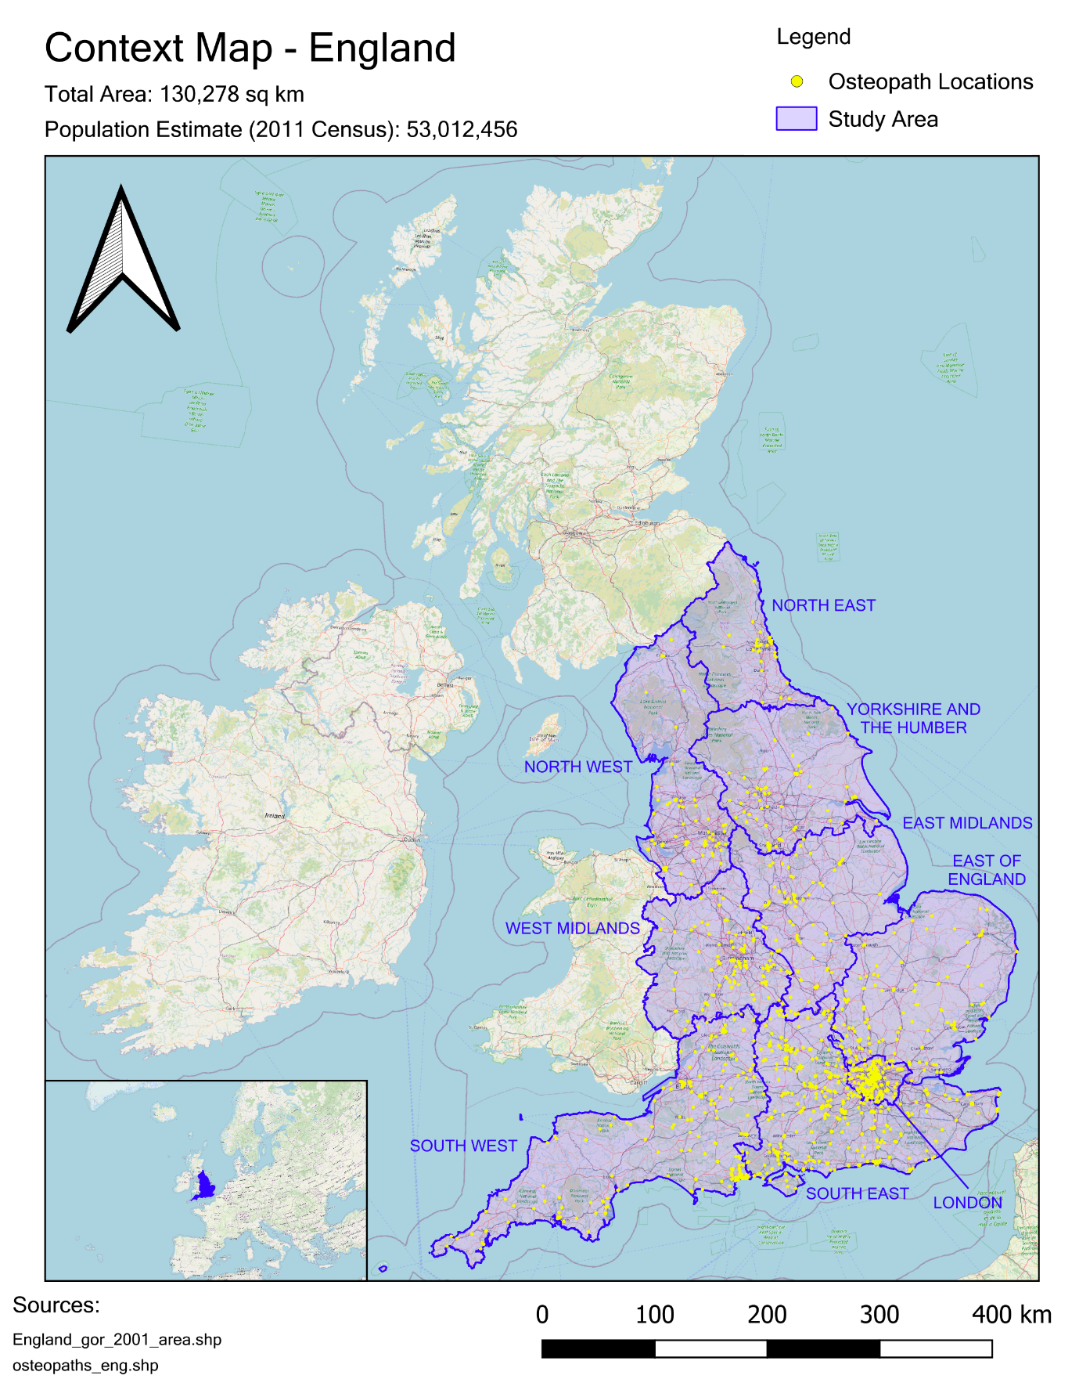
Figure 1.
We can make some initial observations from this map. Osteopathic practices are spatially clustered and line up with the locations of UK towns and cities – especially in the Southeast and Southwest. There is an especially large concentration in London, which may not be solely due to its large share of England’s population. There still appears to be a significant correlation with population, as Figure 2 shows.
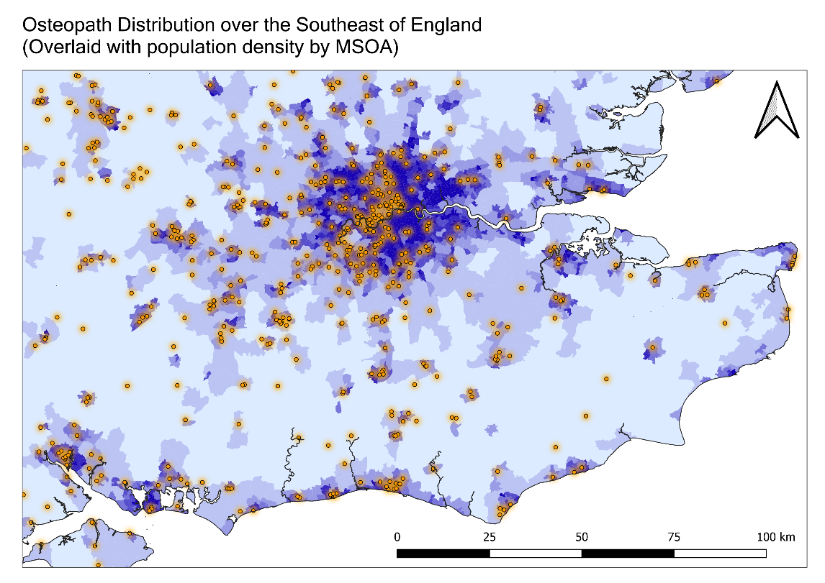
Figure 2.
A visualization of osteopaths per Local Authority could also be made. Such a method would fail to account for the inconsistent sizes of each Local Authority, however. To remedy this, a new field is created by dividing the total osteopath practices in each LA by its area to get a proportional measure of Osteopath location density in each local region of England.
This column effectively represents the spatial distribution of practices; in effect showing how accessible such services are in terms of travel time. However, there is a second dimension of distribution to consider: how many people each osteopath serves. As the number of staff can vary within each individual practice, the previous sum of practices is weighted by the ‘OSTEOPATHS’ column to get the number of osteopaths – not practices - within each LA. SPSS’ Descriptive Statistics function allows us to sum MSOA populations by the Local Authority they are under by grouping each total by LAD11NM, the unique name each LA uses. Dividing the number of osteopaths by this field gives a ‘rate’ of osteopaths in local regions.
Figure 3 exhibits the sequence of field calculations and functions used to create these columns. The outcomes are mapped in the Results section.

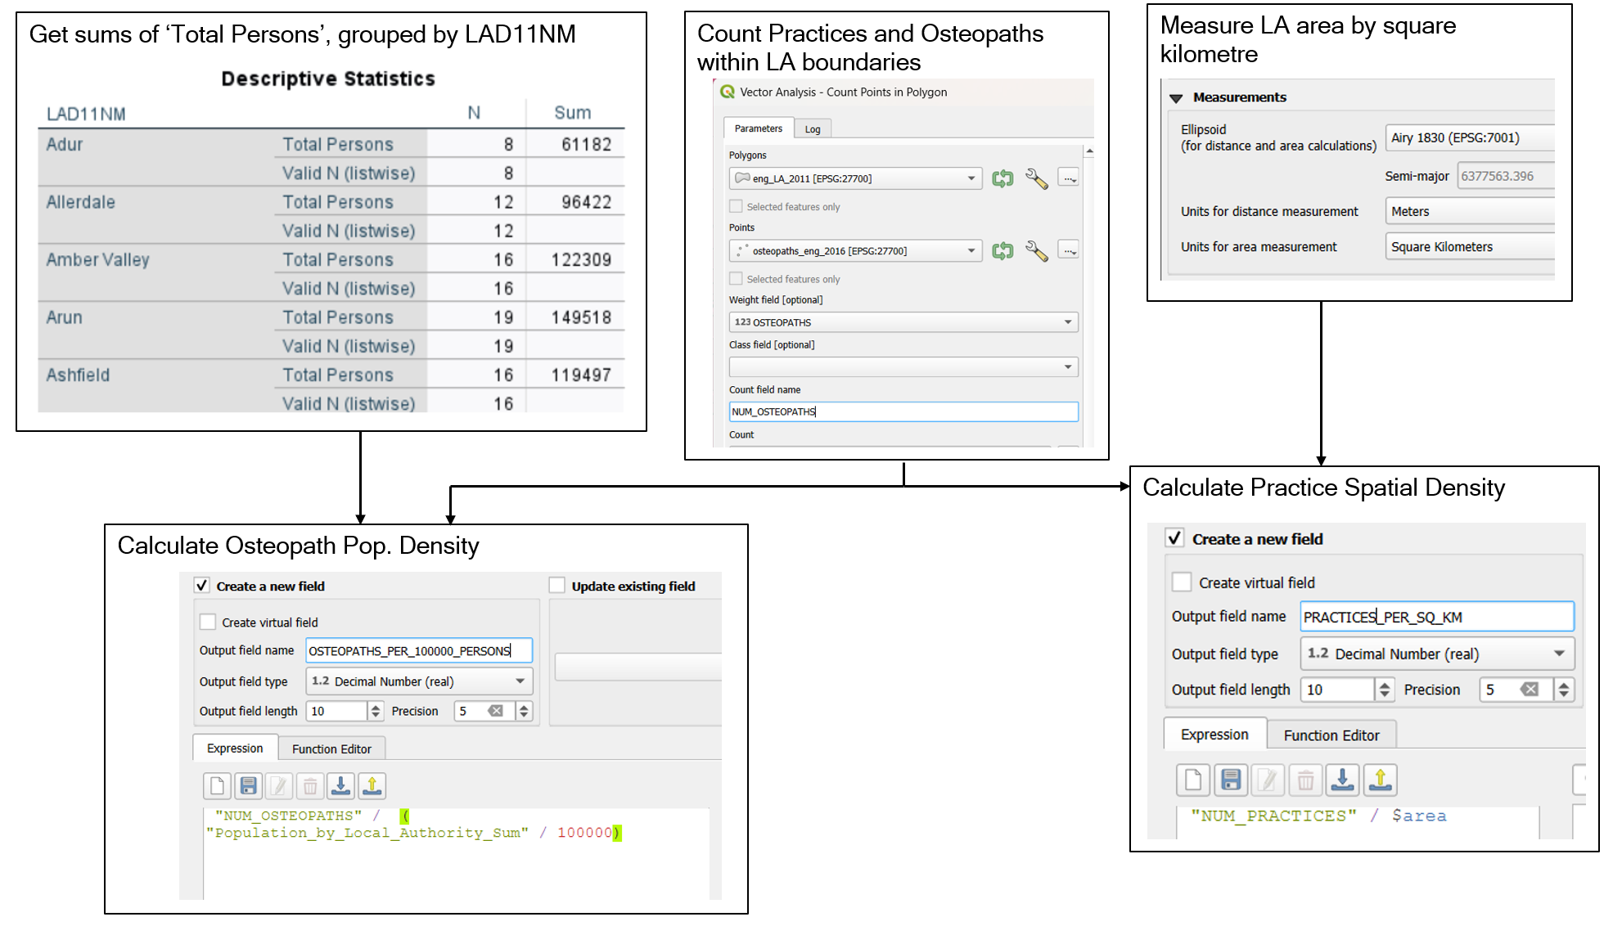
Figure 3.

Correlations and Descriptives
The selected variables detailed earlier are all present in the SPSS dataset. There are a few caveats to handle before true classification can begin, however.
Firstly, the scale of these variables is inconsistent as seen in Figure 4. This is exemplified by ‘Primary production occupation’, which has a miniscule 0.2 standard deviation while other variables range from 1 to 18. This imbalance is the result of primary production occupations such as mining or fishing being rarer in the UK (Office of National Statistics, 2011a), which causes a relatively small degree of variance when put up against other variables. Such mismatched scale creates problems during classification as ‘smaller’ statistics will have a lessened weighting despite potentially having a stronger effect in the real world. Likewise, factors that vary greatly such as ‘Owner Occupiers’ might have a bias despite their minor importance. Solving this issue will require standardising our selected variables by calculating their Z-scores; in other words, how many standard deviations each value is from its overall mean.
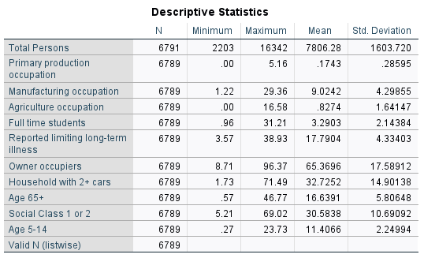
Figure 4.
Creating a correlation heatmap of the selected variables shows their relationships. Figure 3 shows these results with strongly positive correlations highlighted in blue and strongly negative correlations in red. Weaker but still significant correlations have a less intense colouring.
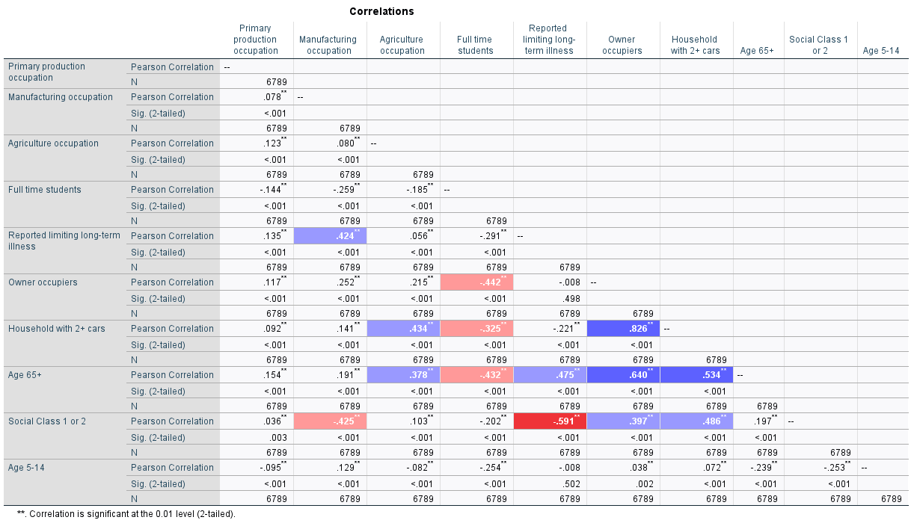
Figure 5.
‘Social Class 1 or 2’ has several interesting correlations. For instance, it has a strong negative relation to ‘% reporting long-term limiting illness’, implying that those in higher social classes are less likely to be in poor health. In contrast ‘Households with 2+ cars’ and ‘Owner Occupiers’ have a strong positive connection. Due to their similarity this is likely to be multicollinearity, so we will drop one to avoid redundant variables.

Additive vs. Multivariate Classification
Multivariate Label-based Classification will be used for this project. This is in part due to the large number of selected variables; 8 factors will mean that an additive index may be muddled. As we are looking for discrete ‘types’ of consumer, a labelling system would also be more appropriate as opposed to a composite score. And given that there are two degrees of osteopath suitability (Illness and Wealth) that can vary in opposition to each other, a simple decimal figure is unlikely to capture useful ratings.
K-Means clustering was used for 50 iterations to create 5 key clusters, leading to the results in Figure 6. Each cluster has been given a concise name that represents the demographic it contains, with the reasons for these names being explained below. 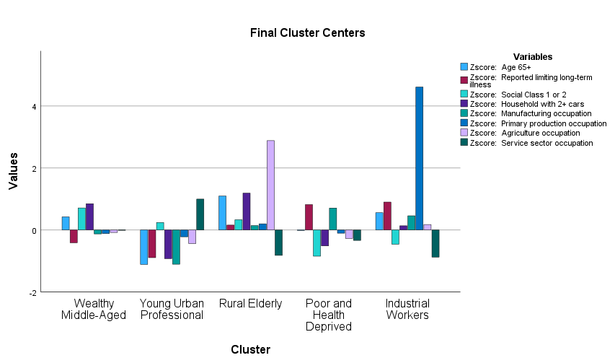
Figure 6.
- Cluster 1 – Wealthy Middle-Aged: This cluster has the largest proportion of high social classes and high rates of multiple car ownership, indicating a wealthy population. Given the slight positive deviation of ‘Age 65+’, we could infer that demographics in this group are generally middle-aged.
- Cluster 2 – Young Urban Professional: Very low ‘Age 65+’ values and a high prevalence of service occupations indicate a youthful office-based workforce (The ‘Service sector occupation’ variable was added to contextualise this cluster). The distribution of this cluster shows that almost all these MSOAs are within cities, hence the ‘Urban’ component.
- Cluster 3 – Rural Elderly: The highest rates of ‘Age 65+’ tells us directly that this is primarily an elderly demographic. Additionally, the large proportion of Agricultural jobs and car ownership implies a rural environment.
- Cluster 4 – Poor and Health Deprived: This cluster unfortunately trends towards the highest rates of long-term illness and manufacturing jobs, which are less well-paid on average (National Careers Service, 2025). It also has the lowest values of ‘Social Class 1 or 2’.
- Cluster 5 – Industrial Workers: This cluster features the highest levels of Primary Production jobs by a large margin. It is also the smallest cluster, indicating that these workers tend to be tightly clustered together in specific regions.
It is important to remember that these demographic classifications were made with relevance to Osteopathy in mind and have hence made broad generalizations of many diverse MSOAs to highlight specific groups. To assume that this data represents every resident of each area is an ecological fallacy.

Results & Discussion

Osteopath Distribution
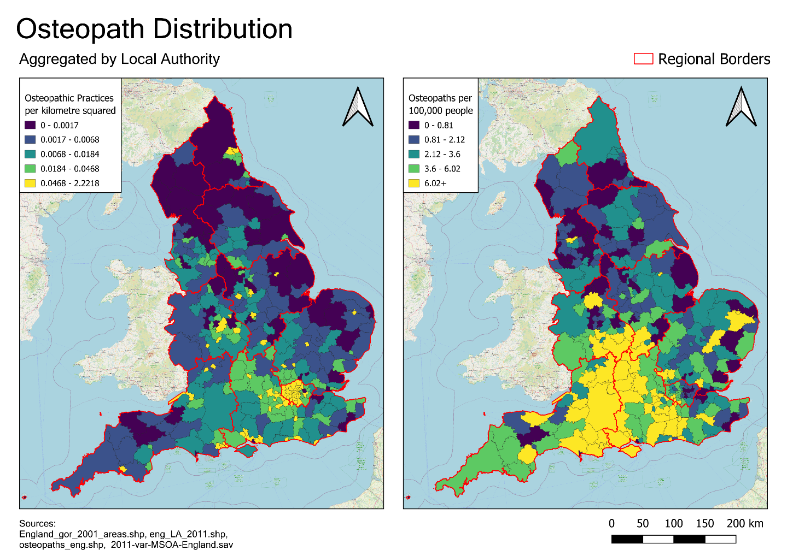
Figure 7.
Our initial observations regarding clustering in the south are validated by these maps, which show a clear imbalance in Osteopath density that is centred on the Southeast and the eastern part of the Southwest. The north is underserviced in comparison; especially in the populous Liverpool-Manchester-Leeds conurbation. While most of London shares this southern bias, its eastern boroughs are lacking in comparison.
From this interpretation, we can inform our recommendations for future practice locations in several ways:
- Avoid placing new osteopaths in the central southern regions of England, as these areas already have plenty per person.
- Despite its southern proximity, East London may need new practices.
- Prioritise northern MSOAs - especially those in or around Liverpool, Manchester and Leeds.
- Avoid placing new practices in remote areas due to low populations and limited transport links.

Geodemographic Classification
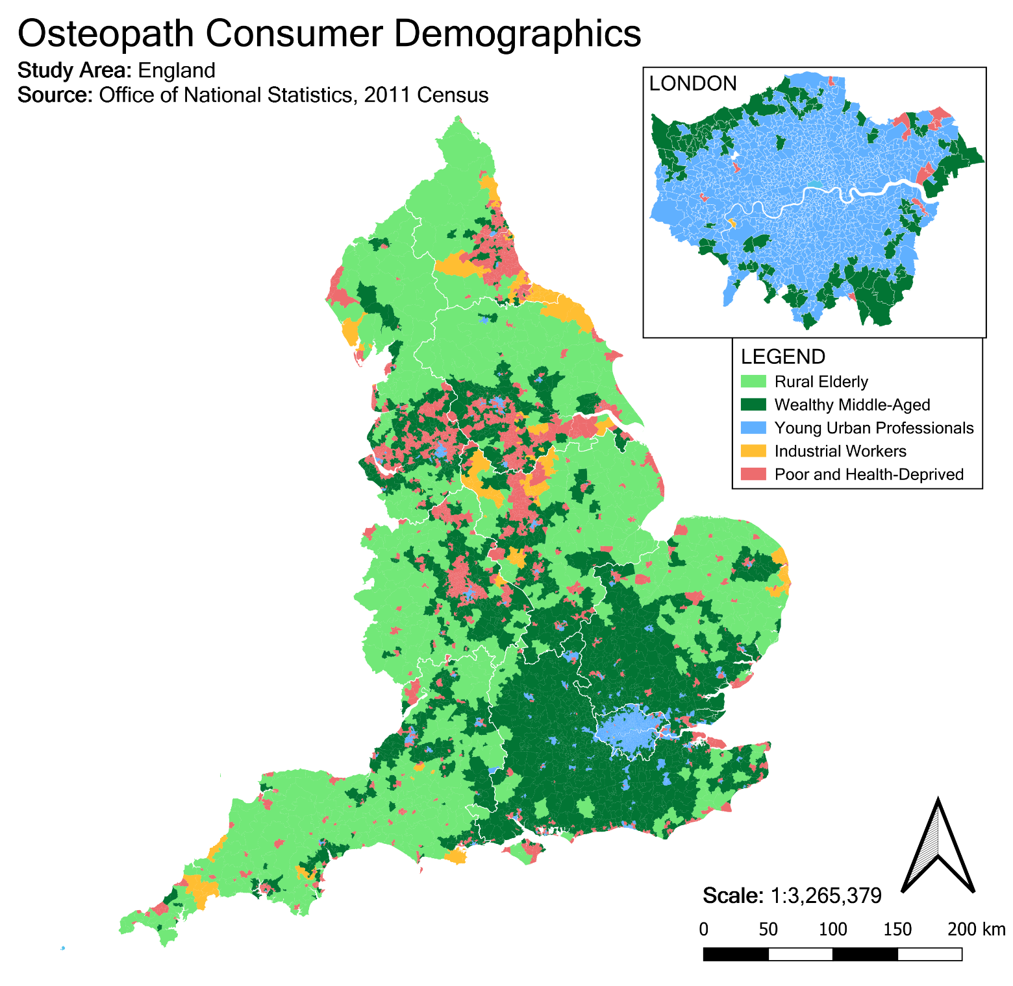
Figure 8.
The classification map in Figure 8 has revealed quite a few regional trends and will be the primary influence on our recommendations.
The Rural Elderly demographic is by far the most widespread, encompassing most of England’s countryside. While this is one of the most suitable demographics due to typical elderly health issues combined with the above average wealth of rural retirees, we could argue it has been sufficiently serviced in the south based on the previous distribution; to put it another way, the supply has met the demand in these areas. Instead, Rural Elderly regions in the north could be prioritised.
General wealthy populations cluster around major cities, especially London. A separate window for London has been created due to the minimal size of MSOAs in that area combined with its large share of the population. Most of the city is classified as young professionals but there are some areas of health deprivation in the eastern boroughs. The wealthy outlying suburbs may be the best target for new practices here, as they will likely have the means to pay as well as the health issues that demand osteopathy.
Based on the coastal and northern placement of Industrial Worker MSOAs, they may be focused on fishing and mining respectively. It may be better to prioritize the fishing industries for osteopaths, as coastal Industrial MSOAs seem to be clustered adjacent to wealthy ones.

Conclusion

New Practice Locations
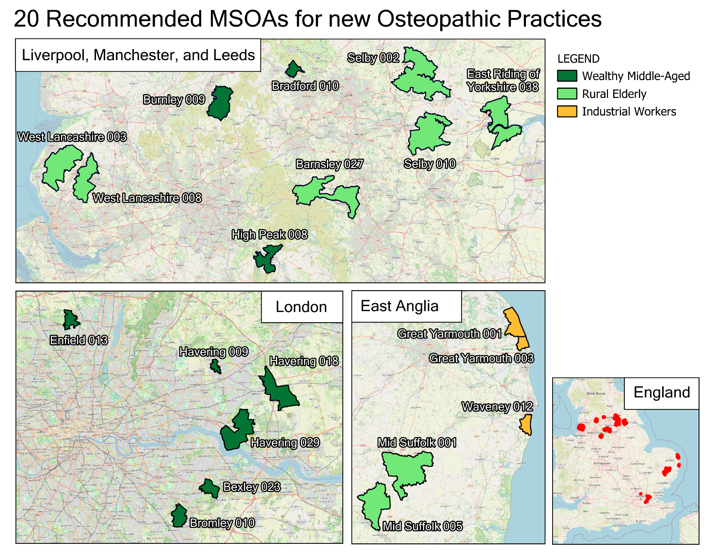
Figure 9.
The final recommendations for new practices are mapped above. They were made by comparing consumer demographics to current distribution to identify MSOAs with the highest need, highest incomes, and lowest current supply. The new practice locations fall into three geographical groups.
Liverpool, Manchester and Leeds: These 9 MSOAs form the main block of recommendations for the overlooked north. Their aging populations and general prosperity make them highly suitable.
London: Despite London’s high density of practices, this is not a universal constant for the city. Increasing the number of osteopaths in the eastern suburbs would help offset the imbalance.
East Anglia: The industrial workers here are likely to require treatment, and the abundance of wealthy MSOAs next to these areas indicate a high level of income to pay for it.

References

Bláfoss, R., Skovlund, S.V., López‐Bueno, R., Calatayud, J., Sundstrup, E. and Andersen, L.L. 2020. Is hard physical work in the early working life associated with back pain later in life? A cross-sectional study among 5700 older workers. BMJ Open. [Online]. 10(12), article no: p.e040158 [no pagination]. [Accessed 27 March 2025]. Available from: https://doi.org/10.1136/bmjopen-2020-040158

Cole, A. 2023. How Walking Improves Back Health. [Online]. [Accessed 27 March 2025]. Available from: https://www.spine-health.com/wellness/exercise/how-walking-improves-back-health#:~:text=8,j.pmrj.2013.11.002

GOC. 2025. How much does treatment cost?. [Online]. [Accessed 22 March 2025]. Available from: https://www.osteopathy.org.uk/faqs/how-much-does-treatment-cost/

Leach, C.J., Mandy, A., Hankins, M., Bottomley, L.M., Cross, V., Fawkes, C.A., Fiske, A. and Moore, A.P. 2013. Patients’ expectations of private osteopathic care in the UK: a national survey of patients. BMC Complementary and Alternative Medicine. [Online]. 13(1), article no: 122 [no pagination]. [Accessed 27 March 2025]. Available from: https://doi.org/10.1186/1472-6882-13-122

National Careers Service. 2025. Production worker (manufacturing). [Online]. [Accessed 9 April 2025]. Available from: http://nationalcareers.service.gov.uk/job-profiles/production-worker-manufacturing

NHS. 2024. Osteopathy. [Online]. [Accessed 22 March 2025]. Available from: https://www.nhs.uk/conditions/osteopathy/

Office of National Statistics, 2011a. 2011 Census: Key Statistics and Quick Statistics for Local Authorities in the United Kingdom. [Online]. London: National Archives. [Accessed 5 April 2025]. Available from: https://www.ons.gov.uk/employmentandlabourmarket/peopleinwork/employmentandemployeetypes/bulletins/keystatisticsandquickstatisticsforlocalauthoritiesintheunitedkingdom/2013-12-04/pdf

Office of National Statistics, 2011b. Household Questionnaire - England. [Online]. London: National Archives. [Accessed 7 April 2025]. Available from: https://webarchive.nationalarchives.gov.uk/ukgwa/20160105160709/http://www.ons.gov.uk/ons/guide-method/census/2011/the-2011-census/2011-census-questionnaire-content/2011-census-questionnaire-for-england.pdf

Office of National Statistics, 2011c. 2011 Census Variable and Classification Information: Part 4. [Online]. London: National Archives. [Accessed 7 April 2025]. Available from: https://webarchive.nationalarchives.gov.uk/ukgwa/20160105160709/http://www.ons.gov.uk/ons/guide-method/census/2011/census-data/2011-census-user-guide/information-by-variable/part-4--derived-variables.pdf

Plunkett, A., Fawkes, C. and Carnes, D. 2022. Osteopathic practice in the United Kingdom: A retrospective analysis of practice data. PLOS ONE. [Online]. 17(7), article no: p.e0270806 [no pagination]. [Accessed 27 March 2025]. Available from: https://doi.org/10.1371/journal.pone.0270806

‌

